**DESIGN AND IMPLEMENTATION OF AUTOMATED TELLER MACHINE (FSM) CONTROLLER**

Submitted by:

Pavan Naik

Nitte Meenakshi Institute of Technology, ECE Dept, Bangalore.

Harshitha S K

Nitte Meenakshi Institute of Technology, ECE Dept, Bangalore.

Keerti M

Nitte Meenakshi Institute of Technology, ECE Dept, Bangalore.

Submitted to:

Institution Mentor

Dr. Rajesh.N

Professor, ECE Dept.

**Abstract: The ATM System is the project which is used to access their bank accounts in order to make cash withdrawals. Whenever user want to make withdrawals, they can enter their ATM card and verified PIN, then user select the withdrawal option and enter the withdrawal amounts.** **The whole process will be automated right from PIN validation to transaction completion. The card details and PIN database will be a secure module that will not be open to routine maintenance, the only possibility of access to this database will be through queries(questions) raised from an ATM in the presence of a valid bank ATM card. ATM Simulation System will enable two important features of an ATM, reduction of human error in the banking system and the possibility of24 hour personal banking**

# Introduction

An automated teller machine (ATM) is an electronic telecommunications device that enables customers of financial institutions to perform financial transactions, such as cash withdrawals, deposits, funds transfers, balance inquiries or account information inquiries, at any time and without the need for direct interaction with bank staff.

To aid in reliability, some ATMs print each transaction to a roll-paper journal that is stored inside the ATM, which allows its users and the related financial institutions to settle things based on the records in the journal in case there is a dispute. In some cases, transactions are posted to an electronic journal to remove the cost of supplying journal paper to the ATM and for more convenient searching of data.

The designed ATM controller FSM performs the following checks:

* Invalid PIN entry (3 times allowed and later it should lock the account for next 24 hours)
* Withdraw
* Deposit
* Old balance and new balance display
* Mini statement for the recent transactions

# Literature Survey

1. “ATM SYSTEM”, submitted by Ayush Sharma, Galgotias university, Uttar Pradesh, 2011.

* here the ATM will provide the customer with a printed receipt for each successful transaction, the date, time, machine location, type of transaction, accounts and ending and available balance of the affected account.

1. Stuart Sutherland, Simon Davidmann, Peter Flake, “System Verilog for Design: A Guide to Using System Verilog for Hardware Design and Modelling”, Springer publications, 2nd Edition.

* this textbook gives the detailed method to program the FPGAs using system Verilog.

1. Maddela Subha Sri, Dr. J. Krishna Chaithanya, Nelli Dhruthiee, “Design and Implementation of Smart ATM under IDLE Application”, 7th International Conference on Communication and Electronics Systems (ICCES), 2022.

* Here RFID scanner, Finger Print scanner, web camera, GSM module and OTP are the major security features used to complete the system.

1. Field Programmable Gate Array Technology - S. Trimberger, Edr, 1994, Kluwer Academic Publications

* This textbook gives detail perspective about field programmable gate arrays.
* It says about method to program and reprogram the FPGA for different digital circuits and device

# Block Diagram

The block diagram of the automated teller machine consists of mainly two input devices and four output devices. The input devices like card reader and keypad whereas output devices are speaker, display screen, receipt printer, and cash depositor.

ATM (FSM) Controller

Card_inserted

Card_valid

Pin_valid

Pin_entry

deposit

withdraw

Amount_entry

Face_verified

Show_statement

Show_balance

Deposit_ok

Pin_correct

Account_locked

Withdrawal_ok

Face_recognition

clock

reset

Mini_statement

Fig1: Block Diagram of ATM (FSM) Controller

# FSM model

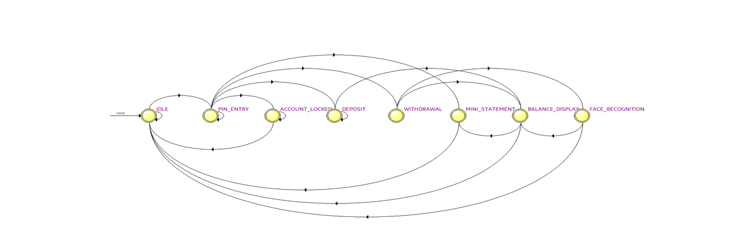

Fig 2: FSM of the designed ATM Controller

# Approach to solve the problem

To solve the problem of implementing an Automated Teller Machine (ATM) Controller using a Finite State Machine (FSM) design, the following approach if followed:

1. Identification of the requirements: Understanding the functional and non-functional requirements of the ATM Controller such as customer authentication, transaction processing, account blocking and any specific constraints or regulations.

2. Defining the states: The different states that the ATM can be in during its operation were defined. These states include idle, card insertion, PIN entry, transaction selection, transaction processing, account lock state and completion states.

3. Determination of the events: Identify the events that can trigger state transitions in the ATM Controller. Events can include actions performed by the user such as card insertion, PIN entry, transaction selection, etc.

4. Defining the transitions: Mapped out the valid transitions between states based on the events that occur and also specified the conditions under which a transition can occur, such as successful PIN entry or the presence of sufficient funds.

1. Designing the action logic: For each state transition, the actions or operations that need to be performed are determined. These actions include validating the user’s credentials, processing the transactions, etc.
2. Handle error scenarios: Identify potential error conditions and define how the ATM Controller should handle them. This includes scenarios such as invalid card insertion, incorrect PIN entry, insufficient funds, etc. Also, the appropriate error states and recovery mechanisms are specified.
3. Implementation of the FSM: Based on the defined states, transitions, and actions, the FSM-based ATM Controller using the programming language of your choice are implemented. The Verilog HDL is used to implement the mentioned FSM.

8. Test and validate: Test cases to verify the correctness and robustness of the ATM Controller are developed. Testing various scenarios, including normal operations, edge cases, and error conditions. Validation of the system against the defined requirements to ensure it meets the desired functionality and performance.

By following this approach, you can effectively design, implement, and maintain an ATM Controller using the FSM design paradigm.

# Flow chart

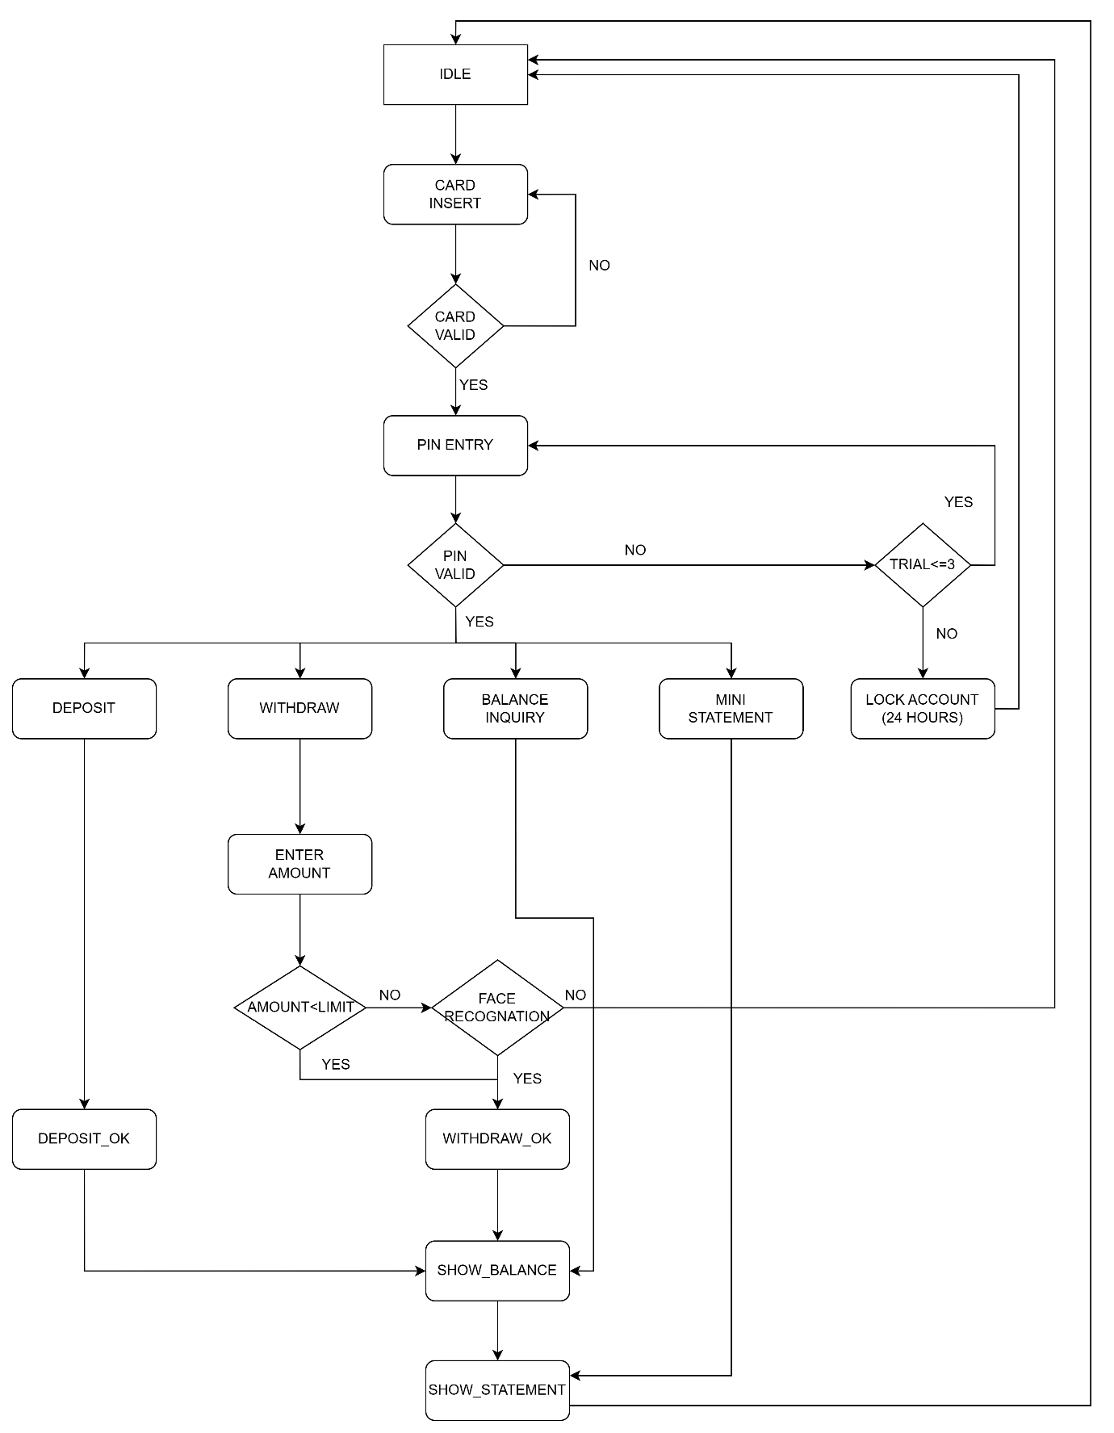

Fig 3: Flow Chart of the ATM Controller (FSM)

# Files uploaded in the Github

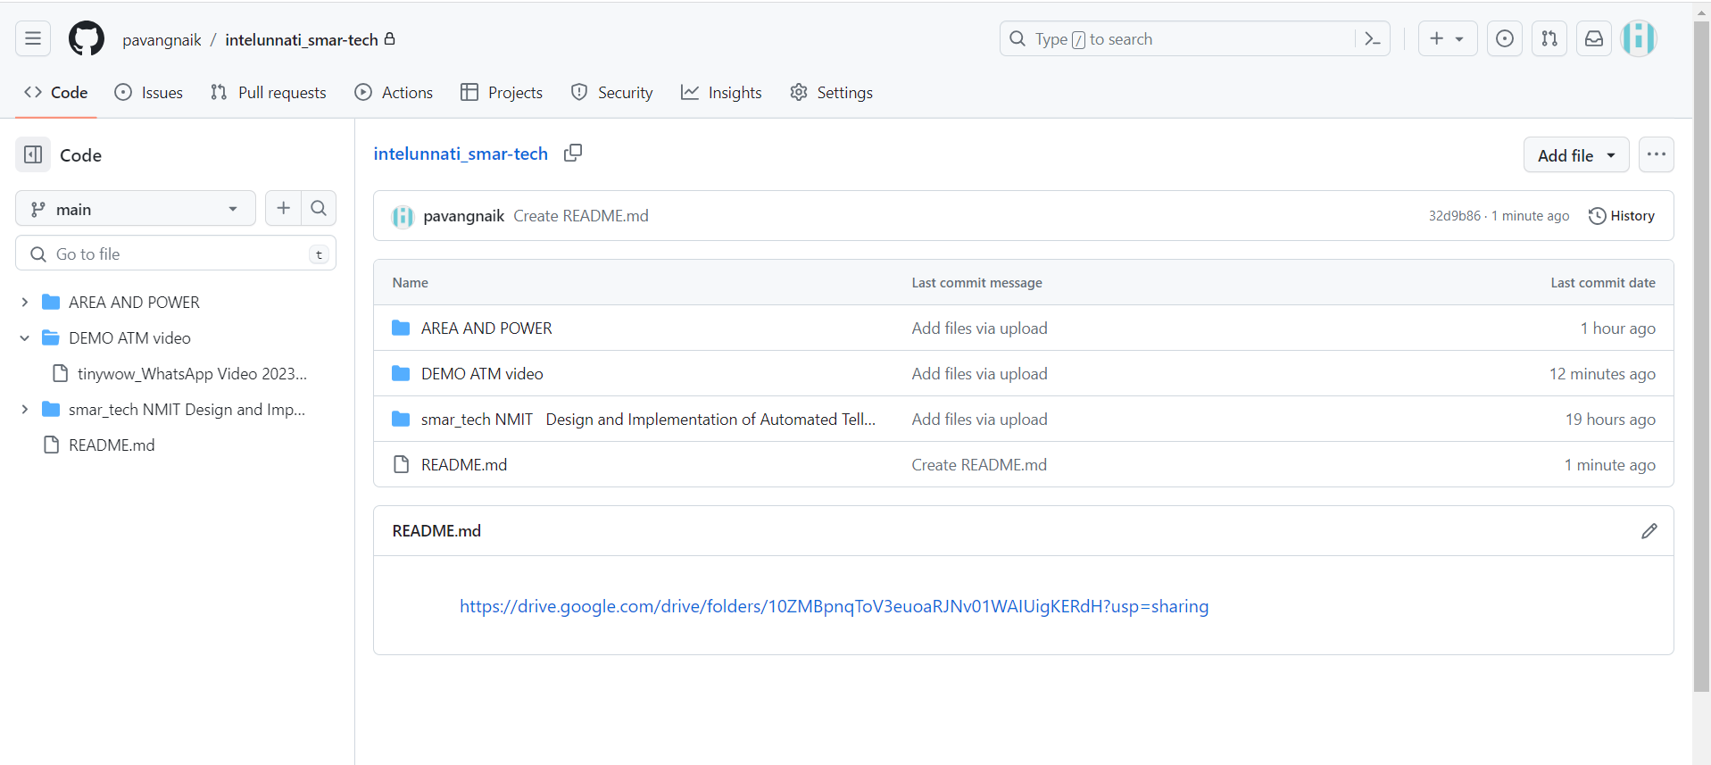

# Video demonstrating the work

<https://drive.google.com/drive/folders/10ZMBpnqToV3euoaRJNv01WAIUigKERdH?usp=sharing>

# Result

* + 1. Waveform Generated

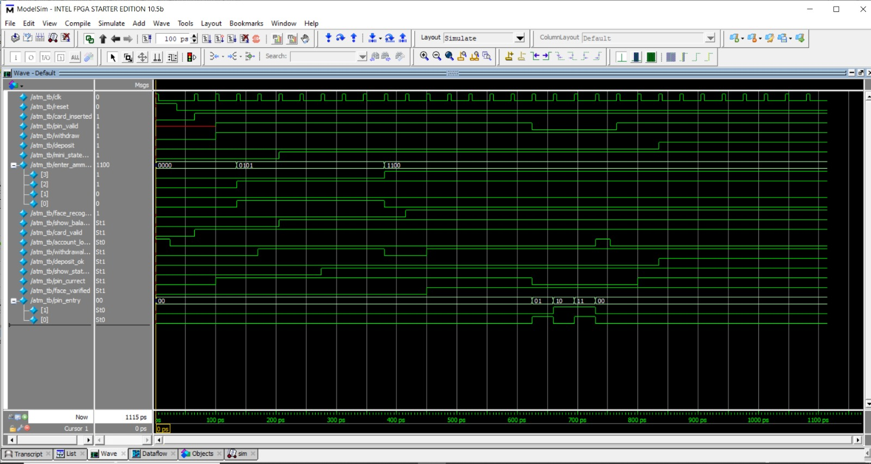

* + 1. Post mapping

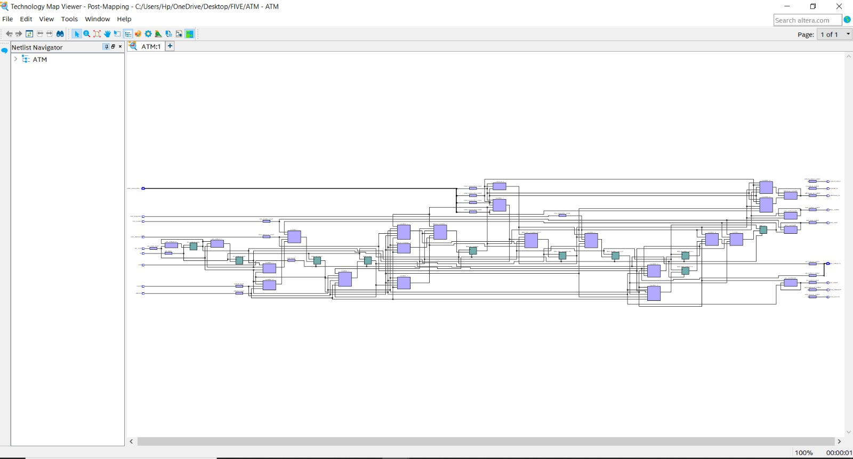

* + 1. Post Fitting

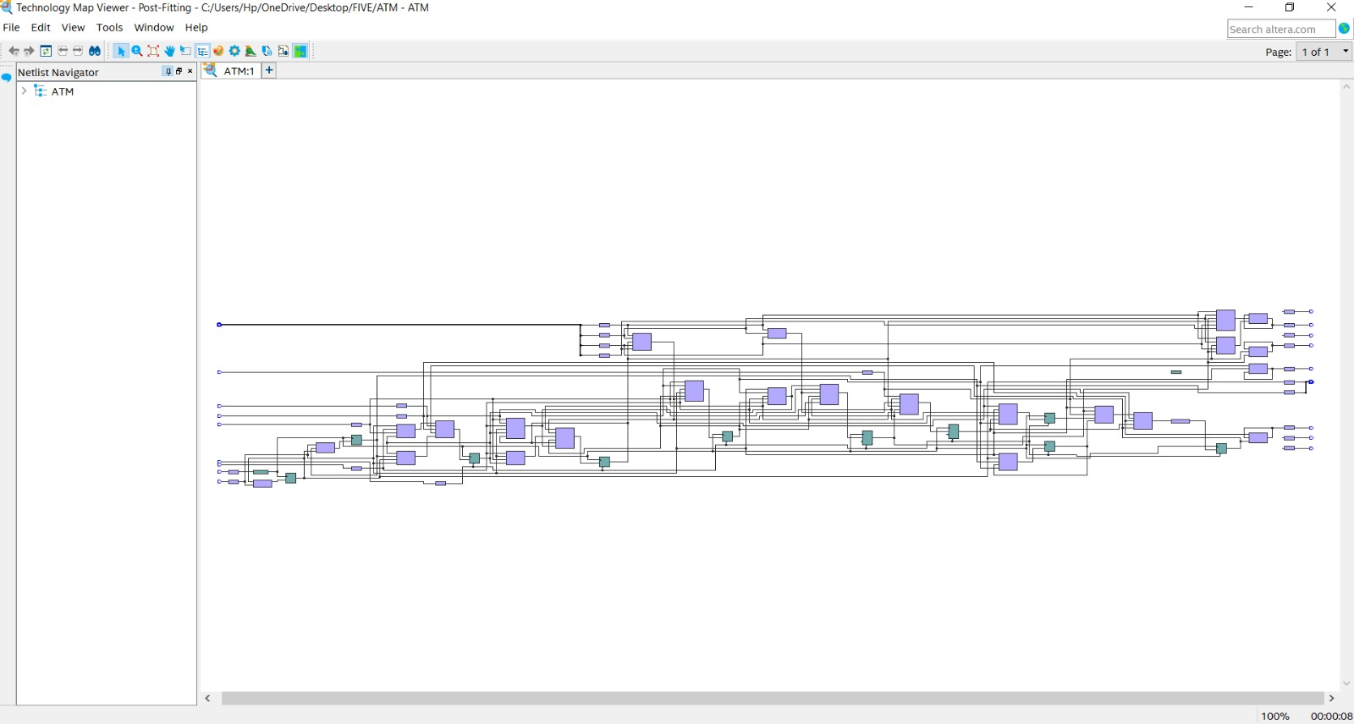

# Summarizations

* + - 1. Area Report:

|  |  |
| --- | --- |
| **Resource** | **Usage** |
| ALMs used in final placement | 20 |
| ALMs used for LUT logic and registers | 4 |
| ALMs used for LUT logic | 14 |
| ALMs used for registers | 2 |
| ALMs used for memory | 0 |
| Total LABs used | 3 |
| Combinational ALUT usage for logic | 25 |
| Combinational ALUT usage for route-throughs | 1 |
| Dedicated logic registers | 10 |
| Total fan-out | 167 |
| Average fan-out | 2.06 |

* + - 1. Power report:

|  |  |
| --- | --- |
| **Resource** | **Usage** |
| Total Thermal Power Dissipation | 421.12 mW |
| Core Dynamic Thermal Power Dissipation | 0 mW |
| Core Static Thermal Power Dissipation | 411.23 mW |
| I/O Thermal Power Dissipation | 9.89 mW |

# Conclusion

The project Automated Teller Machine (FSM) Controller has been developed efficiently with the conditions specified. The ATM Controller's FSM design allows it to handle a wide range of operations, including customer account verification, cash withdrawal, deposit processing, balance and mini statement inquiries, etc. It ensures that each operation follows a defined sequence of states and transitions, guaranteeing the proper execution of ATM transactions using the secure sensitive user information. As technology advances, the ATM Controller can be further enhanced and adapted to meet evolving customer needs while maintaining a high level of reliability and security.